**Kallam Haranadhareddy Institute Of Technology A CRM application for THECHAISHOP&CO**

# By

**Y L V N P Vyshnavi**

[218x1a42b1@khitguntur.ac.in](mailto:218x1a42b1@khitguntur.ac.in)

# Mahanthi Leela Krishna Prasad

[218x1a4271@khitguntur.ac.in](mailto:218x1a4271@khitguntur.ac.in)

# Sk. Nagul Meeravali

[228x5a4209@khitguntur.ac.in](mailto:228x5a4209@khitguntur.ac.in)

# Nalagatla Suresh

[218x1a42b8@khitguntur.ac.in](mailto:218x1a42b8@khitguntur.ac.in)

**Project Overview**

This project aims to develop a **Customer Relationship Management (CRM) application** for THECHAISHOP&CO to streamline customer interactions, track sales, and enhance business operations. Built on **Salesforce CRM**, the system will include **customer management, order tracking, sales analytics, loyalty programs, and automated workflows**. It will provide **custom dashboards, reports, and mobile accessibility** to improve efficiency and customer engagement. The application will help the business enhance customer retention, optimize sales processes, and make data-driven decisions.

**INTRODUCTION**

THECHAISHOP&CO is a growing business that aims to enhance customer relationships, streamline operations, and improve sales tracking. To achieve this, we are developing a **Customer Relationship Management (CRM) application** tailored to their business needs.

# Objectives

* **Customer Management:** Store and manage customer details, preferences, and interactions.
* **Order Tracking:** Maintain a history of customer orders for better service and personalization.
* **Sales Management:** Track sales performance and analyze revenue

trends.

* **Loyalty Program:** Implement a rewards system to enhance customer retention.
* **Feedback & Support**: Enable customers to provide feedback and request support seamlessly.

# Methodology

1. **Requirements Gathering**: Conducted interviews and surveys with potential food donors, volunteer organizations, and beneficiaries to understand their needs and constraints.
2. **System Design**: Designed a Salesforce-based solution to manage the entire process, from food donation to distribution.
3. **Implementation**: Developed and tested the solution using Salesforce's features like objects, reports, dashboards, and automation tools.
4. **Full Deployment**: Rolled out the final solution to all stakeholders.

# Salesforce Key Features and Concepts Utilized

To build a robust CRM Application for THECHAISHOP&CO, the following Salesforce features and concepts were implemented:

* + **Custom Objects and Fields** – Created objects for Customers, Orders, Transactions, and added custom fields to store relevant data.
  + **Lightning App** – Developed a custom Lightning App for easy navigation and a streamlined user experience.
  + **Tabs** – Configured tabs for quick access to Customers, Orders, and Reports.
  + **Global Picklist** – Standardized values across multiple objects (e.g., Order Status: Pending, Shipped, Delivered).
  + **Page Layouts** – Customized layouts to display relevant fields and sections based on user roles.
  + **Record Types** – Created different record types for Customer Accounts, Order Categories, and other business cases.
  + **Email Templates** – Designed automated email templates for order confirmations, customer feedback requests, and promotions.
  + **Flows** – Implemented Salesforce Flows to automate processes such as order approvals and follow-up emails.
  + **Reports and Dashboards** – Developed interactive reports and dashboards to track sales trends, customer activity, and business performance.

# Detailed Steps to Solution Design

1. **Salesforce developer account creation and activation:**
   * To create developer org:
   * Go to <https://developer.salesforce.com/signup>
   * On the sign up form, enter the following details:

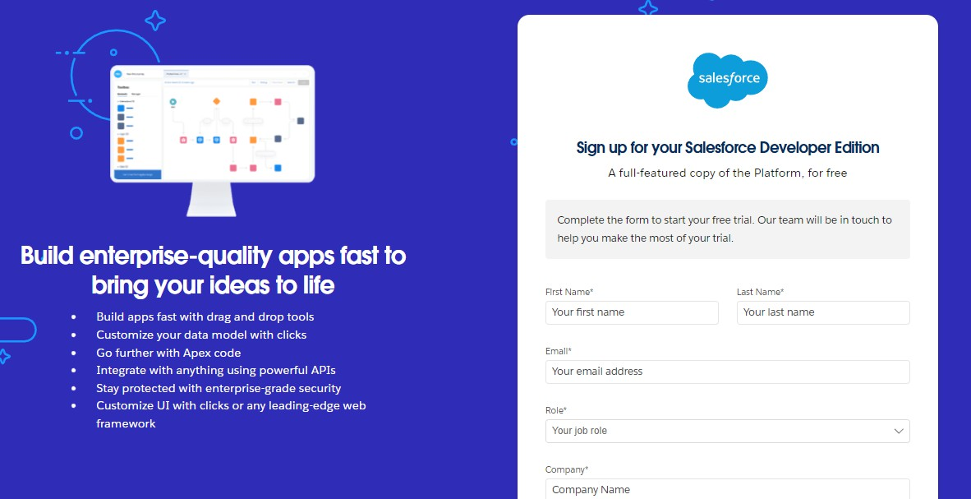

* + For account activation, go to the inbox of the email that you used while signing up. Click on the verify account to activate your account. The email may take 5-10mins.
  + Click on Verify Account.
  + Give a password and answer a security question and click on change password

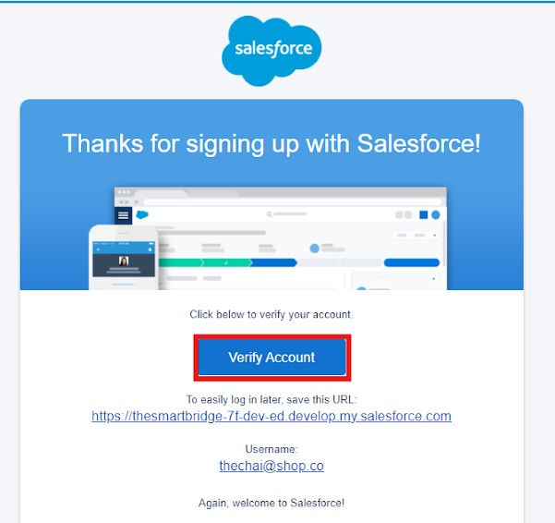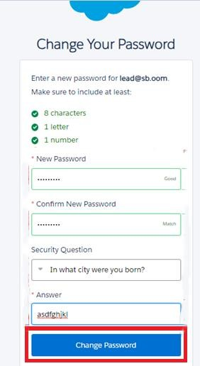

* + Then you will redirect to your salesforce setup page.

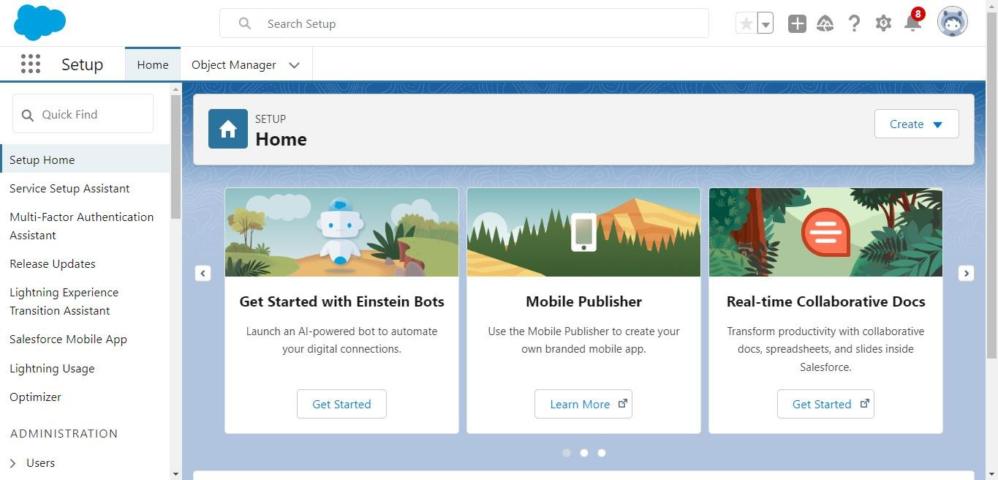

# Custom object creation:

The custom objects that are created are –

* + Employer account object
  + Customer account object
  + Enterprise account object

To create custom object,

Go to salesforce org and click gear icon. Then go to object manager tab and click create | Custom object.

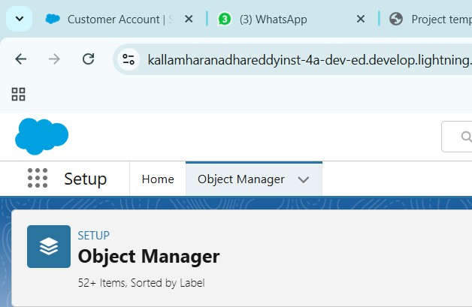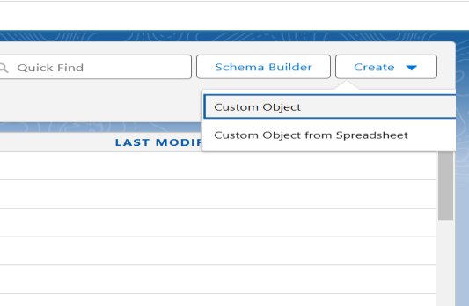

* + Label: Employer Account
  + Plural Label: Employer Accounts
  + Enter Record Name Label and Format
  + Record Name: Employer Account Name
  + Data Type: Text
  + In Optional features: check the boxes for Allow Reports | Allow Activities | Track Field History.
  + Search Status: check the box for Allow Search.
  + Save

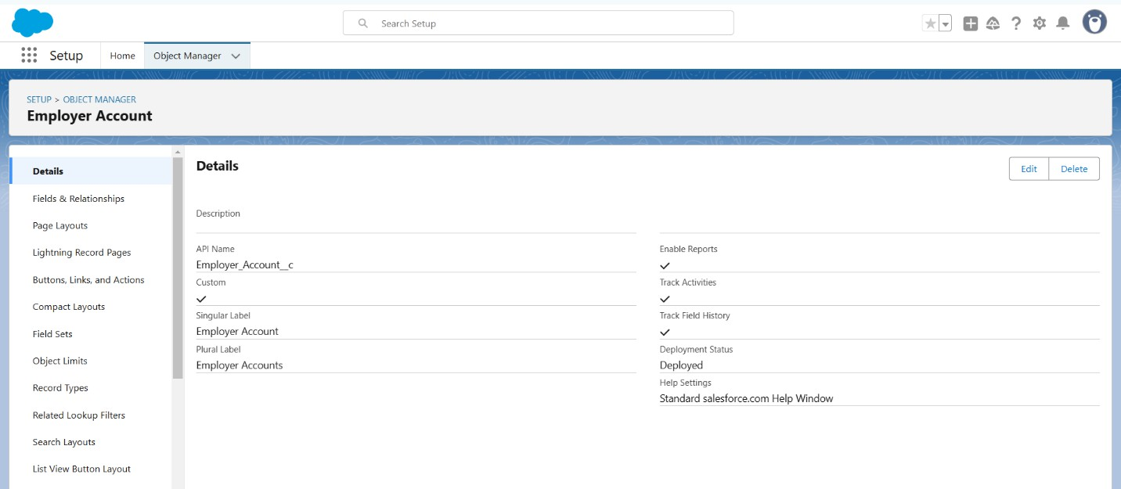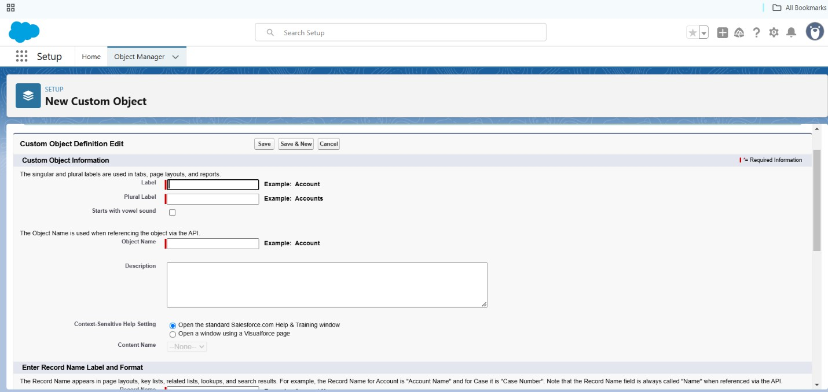

Now repeat the same steps to create customer account object and enterprise account object.

# Custom tabs creation:

* + Go to setup page > Type Tabs in Quick Find bar > click on tabs >New (under custom object tab)

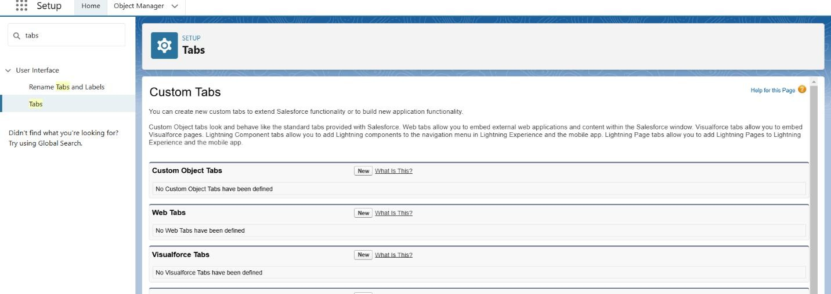

* + Select Object (Employer Accounts) > Select the tab style > Next (Add to profiles page) keep it as default > Next (Add to Custom App) uncheck the include tab.

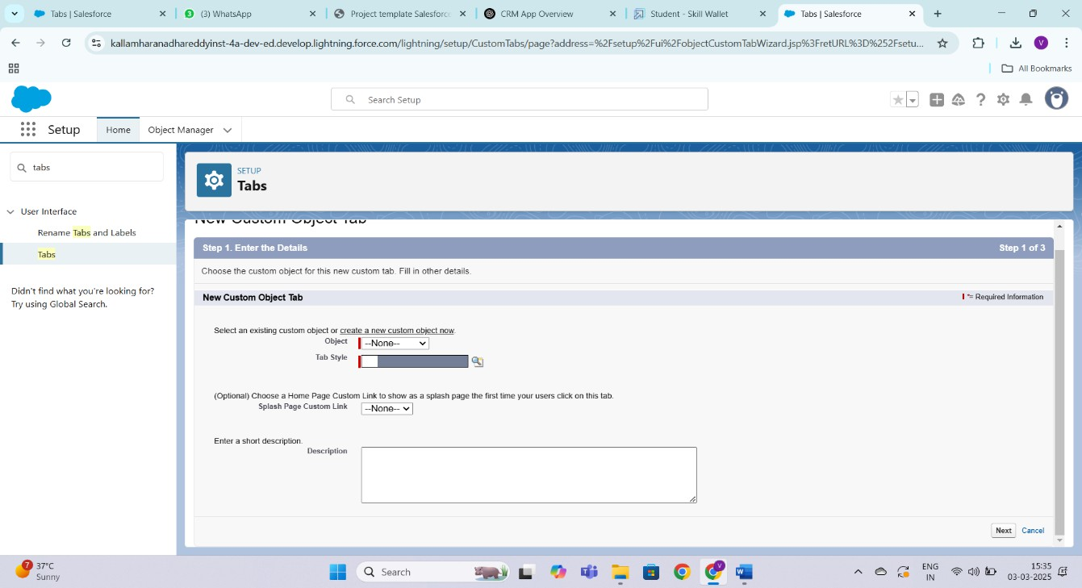

* + Click save.
  + Now repeat the same steps for customer account and enterprise account.

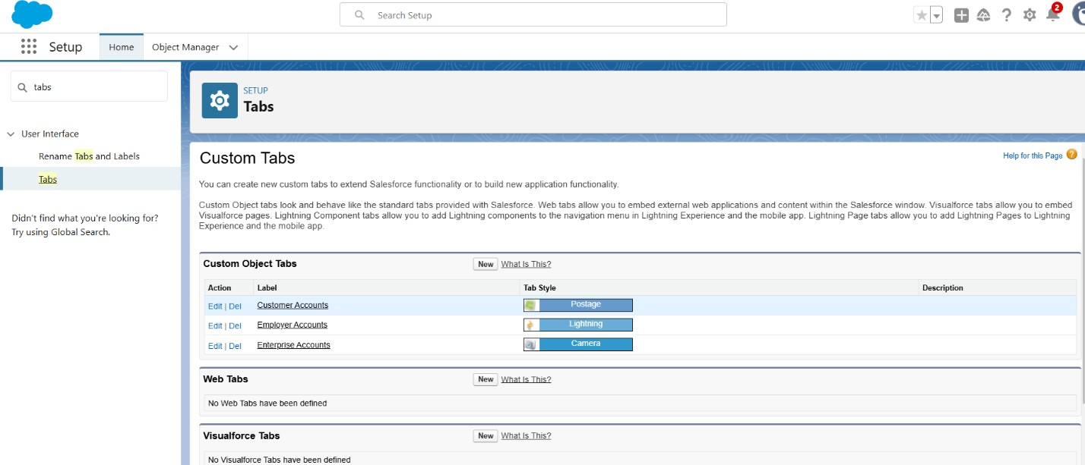

# Create a Lightning app:

* + Go to quick find and search “app manager”. Select it.
  + Then click on “New Lightning app”
  + 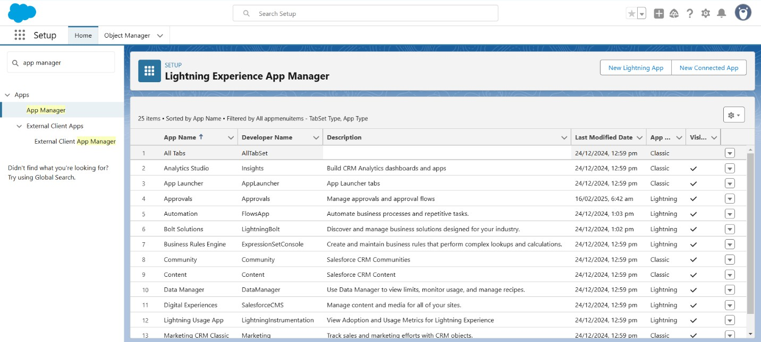Fill the app name in app details and branding as follow App Name: TheChaiShop&Co

Developer Name: Auto Populates

Add Primary color Hex or leave it to default. Then click Next.

* + In App options

Navigation style: Standard navigation Setup experience: setup

Supporters form factors: Desktop and phone Then click Next

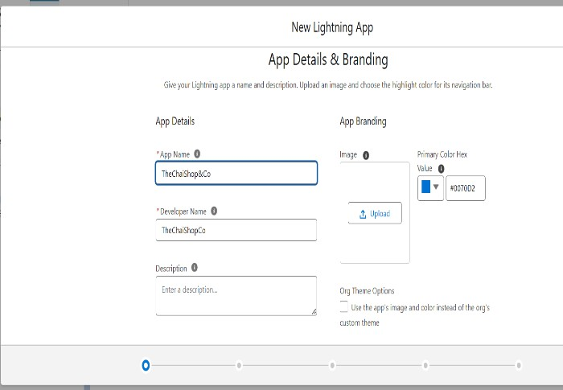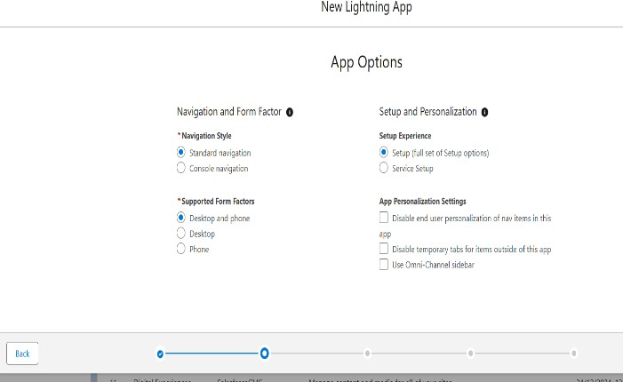

* + Navigation items

Select the created Custom Objects and required standard objects Customer Accounts

Employer Accounts Enterprise Accounts Reports

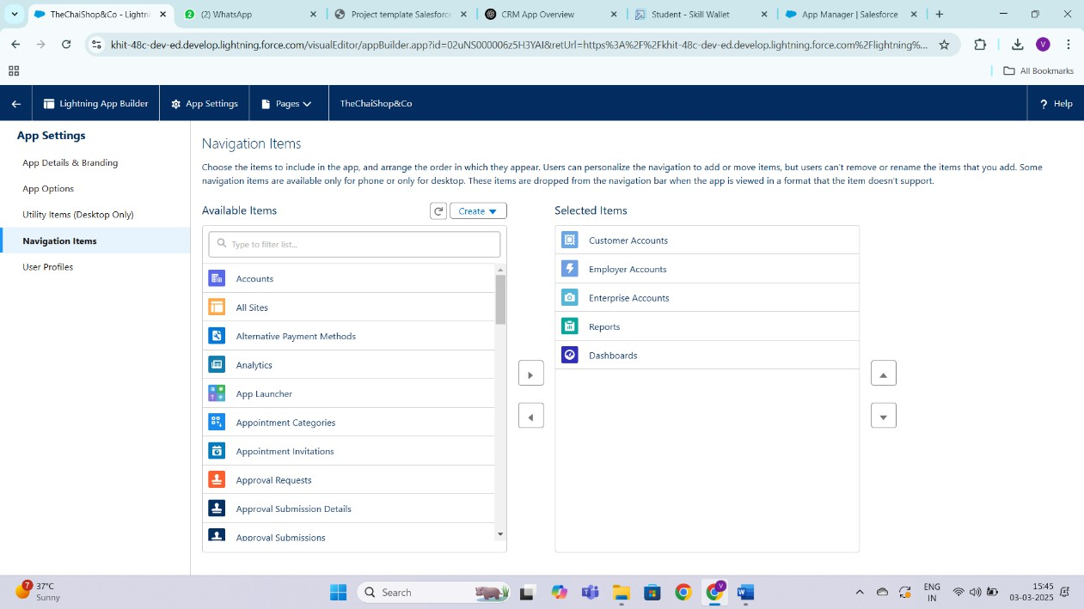Dashboards

* + To Add User Profiles: System Administrator
  + Click Save & Finish.

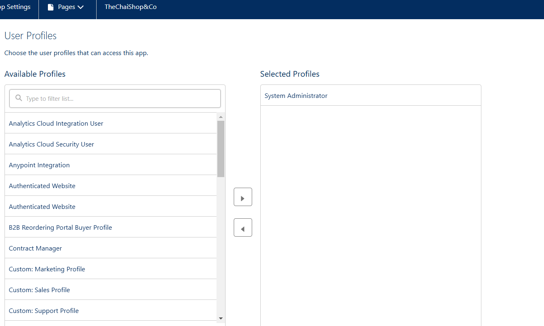

# Global picklist creation:

* + 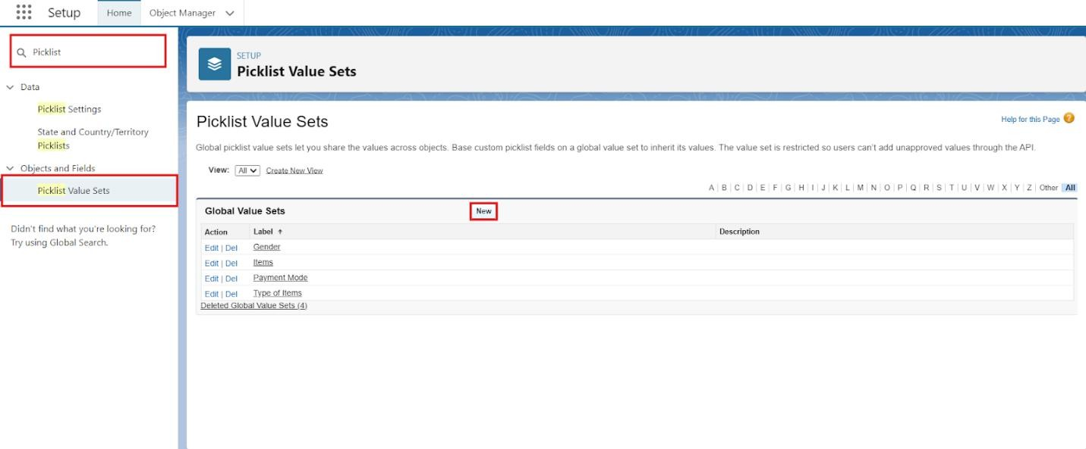In Quick find box search for: Picklist value sets and click New.
  + Label: Gender
  + Name: Auto Populates
  + Values: Male
  + Female
  + Others
  + Click Save & New.

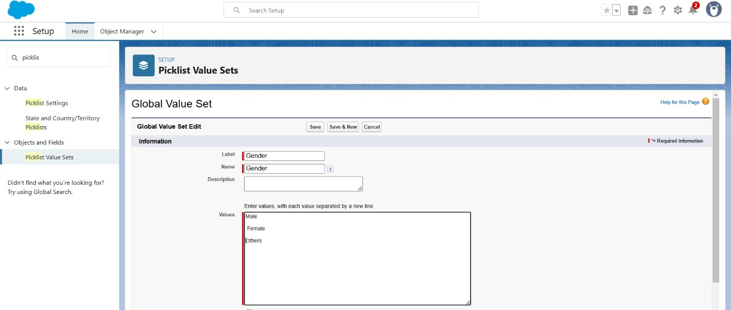

Now repeat the same steps for three more global picklist values with the following details:

Label: Items

Name: Auto populates

Values: Platinum Tea Powder

* + Double Delight Tea Powder
  + Super Dust Tea Powder
  + Osmania Biscuits (Value Pack)
  + Osmania Biscuits (Premium Pack)
  + Dry Fruit Biscuits
  + Fruit Biscuits
  + Salt Biscuits
  + Multigrain Biscuits
  + Ragi Biscuits
  + Double Choco Chip Cookies
  + Butter Almond Cookies
  + Melting Moments Cookies
  + Honey Oats Cookies
  + Delight Box
  + Signature Box
  + Assorted Box Click Save & New. Label: Payment Mode Name: Auto populates Values: Gpay

PhonePe Paytm

Credit or Debit card Cash.

Click Save & New. Label: Type of Items Name: Auto populates

Values: Tea powder

Cookies

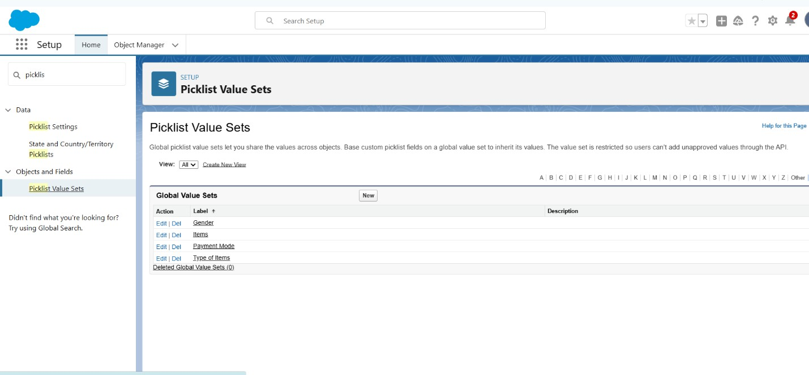Gift Hampers Click Save.

# Fields & Relationships:

In your Salesforce org, click gear icon on the top left and select Setup to open Setup.

From the object manager page, In the Quick Find box, Search for the custom object you just created: Customer Account

From the sidebar, click Fields & Relationships and click new.

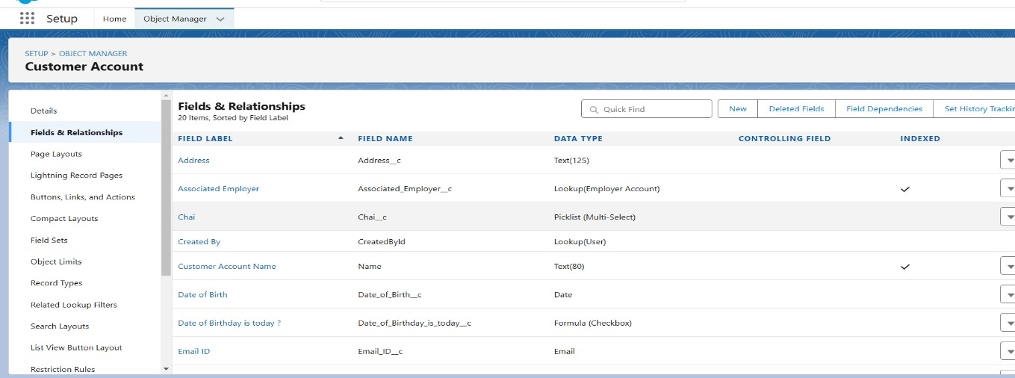

Then select the suitable datatype for the field. Click next and fill in the details.

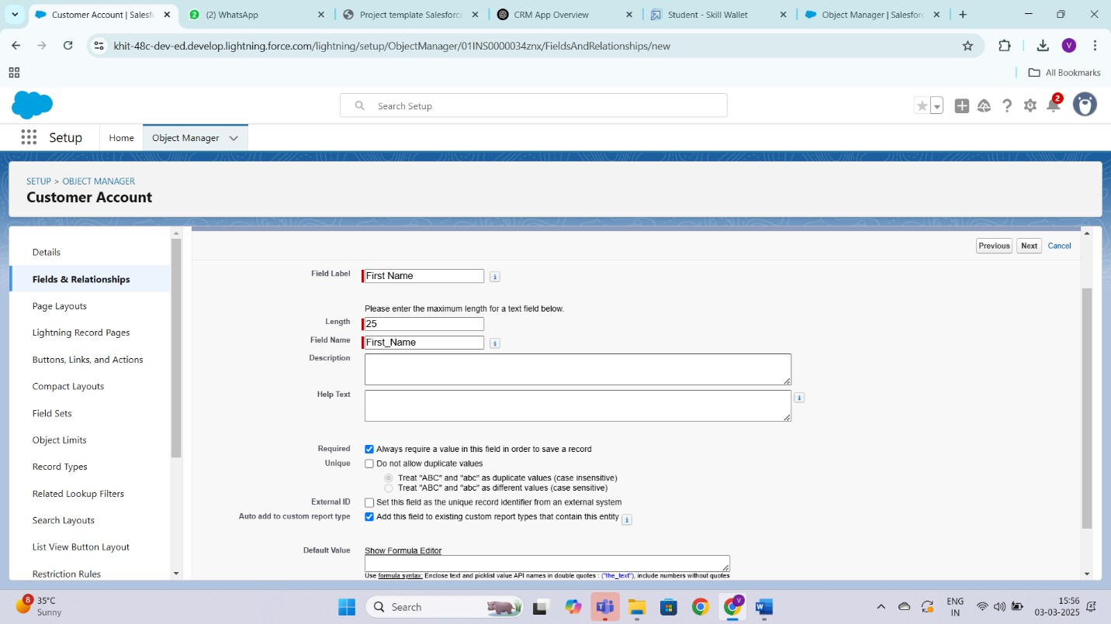

Repeat the same steps for all the fields in all the objects.

## The fields to be created for employer account object are:

1. First Name (Text)
2. Last Name (Text)
3. Gender (Picklist)
4. Phone Number (Phone)
5. Email ID (email)
6. Aadhar Number (Text)
7. DOB (Date)
8. Pan details (Text)
9. Designation (Picklist)(Values: Manager, Finance & Accounting, Kitchen staff, Cashier,Servers)

Values should be separated by new ine.

1. Salary (Currency)

## The fields for customer account object are:

1. First Name (Text)
2. Last Name (Text)
3. Gender (Picklist)
4. DOB (Date)
5. Phone Number (Phone)
6. Date of birthday is today? (Formula) Formula:

IF( AND(

DAY( TODAY() ) = DAY( Date_of_Birth c ) , MONTH ( TODAY()) = MONTH( Date_of_Birth c )), TRUE,

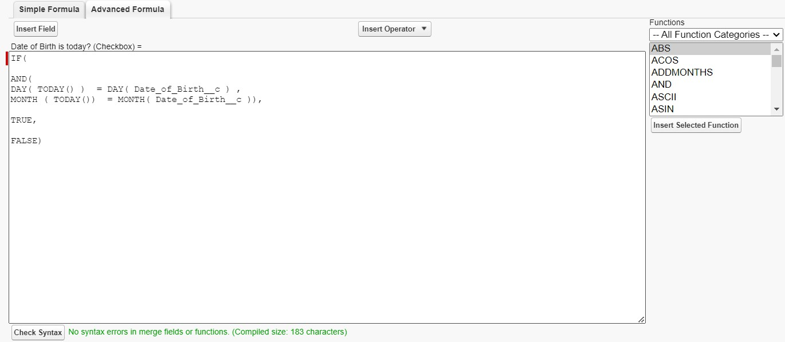FALSE)

1. Email ID (email)
2. Address (Text)
3. Type of items (Multi select picklist) (Values: Select items from dropdowm using global picklist)
4. Product purchased (Multi select picklist) (Values: Select items from dropdowm using global picklist)
5. Chai (Multi select picklist) (Values: Single Tea, Masala Tea, Lemon Tea, Ginger Tea, Green Tea, Sugar free Tea)
6. Payment mode (Picklist)
7. Associated employer (Lookup relationship)(Related to: Employer account)
8. Order quantity (Formula)

Enter Formula = Quantity (Number) =

IF(INCLUDES( Products_Purchased c , "Platinum Tea Powder"), 1, 0 ) + IF(INCLUDES( Products_Purchased c , "Double Delight Tea Powder"), 1, 0 ) +

IF( INCLUDES( Products_Purchased c , "Super Dust Tea Powder") , 1, 0)

+

IF(INCLUDES( Products_Purchased c , "Osmania Biscuits (Value Pack)"), 1, 0 ) +

IF(INCLUDES( Products_Purchased c , "Osmania Biscuits (Premium Pack)"), 1, 0 ) +

IF( INCLUDES( Products_Purchased c , "Dry Fruit Biscuits") , 1, 0) + IF(INCLUDES( Products_Purchased c , "Fruit Biscuits"), 1, 0 ) + IF(INCLUDES( Products_Purchased c , "Salt Biscuits"), 1, 0 ) + IF(INCLUDES( Products_Purchased c , "Multigrain Biscuits"), 1, 0 ) + IF(INCLUDES( Products_Purchased c , "Ragi Biscuits"), 1, 0 ) +

IF( INCLUDES( Products_Purchased c ,"Double Choco chip Cookies") , 1, 0) +

IF(INCLUDES( Products_Purchased c , "Butter Almond Cookies"), 1, 0 )

+

IF(INCLUDES( Products_Purchased c , "Melting Moments Cookies"), 1, 0 ) +

IF( INCLUDES( Products_Purchased c , "Honey Oats Cookies") , 1, 0) + IF(INCLUDES( Products_Purchased c , "Delight Box"), 1, 0 ) + IF(INCLUDES( Products_Purchased c , "Signature Box"), 1, 0 ) +

IF( INCLUDES( Products_Purchased c , "Assorted Pack") , 1, 0) + IF(INCLUDES( Chai c , "TheChaiShop&Co Special Tea"), 1, 0) + IF(INCLUDES( Chai c , "Single Tea"), 1, 0) +

IF(INCLUDES( Chai c , "Masala Tea"), 1, 0) + IF(INCLUDES( Chai c , "Lemon Tea"), 1, 0) + IF(INCLUDES( Chai c , "Ginger Tea"), 1, 0) + IF(INCLUDES( Chai c , "Green Tea"), 1, 0) + IF(INCLUDES( Chai c , "Sugar Free Tea"), 1, 0)

1. Total bill (Formula)

Formula: Enter Formula = Quantity (Number) =

IF(INCLUDES( Products_Purchased c , "Platinum Tea Powder"), 175, 0 )

+

IF(INCLUDES( Products_Purchased c , "Double Delight Tea Powder"), 150, 0 ) +

IF( INCLUDES( Products_Purchased c , "Super Dust Tea Powder") , 125,

0) +

IF(INCLUDES( Products_Purchased c , "Osmania Biscuits (Value Pack)"), 50, 0 ) +

IF(INCLUDES( Products_Purchased c , "Osmania Biscuits (Premium Pack)"), 80, 0 ) +

IF( INCLUDES( Products_Purchased c , "Dry Fruit Biscuits") , 110, 0) + IF(INCLUDES( Products_Purchased c , "Fruit Biscuits"), 160, 0 ) +

IF(INCLUDES( Products_Purchased c , "Salt Biscuits"), 110, 0 ) + IF(INCLUDES( Products_Purchased c , "Multigrain Biscuits"), 170, 0 ) + IF(INCLUDES( Products_Purchased c , "Ragi Biscuits"), 190, 0 ) +

IF( INCLUDES( Products_Purchased c ,"Double Choco chip Cookies") , 200, 0) +

IF(INCLUDES( Products_Purchased c , "Butter Almond Cookies"), 110, 0

) +

IF(INCLUDES( Products_Purchased c , "Melting Moments Cookies"), 150, 0 ) +

IF( INCLUDES( Products_Purchased c , "Honey Oats Cookies") , 160, 0)

+

IF(INCLUDES( Products_Purchased c , "Delight Box"), 850, 0 ) + IF(INCLUDES( Products_Purchased c , "Signature Box"), 1500, 0 ) + IF( INCLUDES( Products_Purchased c , "Assorted Pack") , 600, 0) + IF(INCLUDES( Chai c , "TheChaiShop&Co Special Tea"), 70, 0) + IF(INCLUDES( Chai c , "Single Tea"), 50, 0) +

IF(INCLUDES( Chai c , "Masala Tea"), 60, 0) + IF(INCLUDES( Chai c , "Lemon Tea"), 40, 0) +

IF(INCLUDES( Chai c , "Ginger Tea"),55, 0) + IF(INCLUDES( Chai c , "Green Tea"), 45, 0) +

IF(INCLUDES( Chai c , "Sugar Free Tea"), 55, 0)

## The fields for enterprise account object:

1. Enterprise Name (Text)
2. Phone Number (Phone)
3. Email ID (email)
4. Address (Text)
5. Type of items (Multi select picklist)
6. Products Purchased (Multi select picklist)
7. Associated employer (Lookup relationship)(Related to: Employer account)
8. Order Quantity (Formula)

Enter Formula = Quantity (Number) =

IF(INCLUDES( Products_Purchased c , "Platinum Tea Powder"), 1, 0 ) +

IF(INCLUDES( Products_Purchased c , "Double Delight Tea Powder"), 1, 0 ) +

IF( INCLUDES( Products_Purchased c , "Super Dust Tea Powder")

, 1, 0) +

IF(INCLUDES( Products_Purchased c , "Osmania Biscuits (Value Pack)"), 1, 0 ) +

IF(INCLUDES( Products_Purchased c , "Osmania Biscuits (Premium Pack)"), 1, 0 ) +

IF( INCLUDES( Products_Purchased c , "Dry Fruit Biscuits") , 1, 0)

+

IF(INCLUDES( Products_Purchased c , "Fruit Biscuits"), 1, 0 ) + IF(INCLUDES( Products_Purchased c , "Salt Biscuits"), 1, 0 ) + IF(INCLUDES( Products_Purchased c , "Multigrain Biscuits"), 1, 0

) +

IF(INCLUDES( Products_Purchased c , "Ragi Biscuits"), 1, 0 ) + IF( INCLUDES( Products_Purchased c ,"Double Choco chip Cookies") , 1, 0) +

IF(INCLUDES( Products_Purchased c , "Butter Almond Cookies"), 1, 0 ) +

IF(INCLUDES( Products_Purchased c , "Melting Moments Cookies"), 1, 0 ) +

IF( INCLUDES( Products_Purchased c , "Honey Oats Cookies") , 1,

0) +

IF(INCLUDES( Products_Purchased c , "Delight Box"), 1, 0 ) + IF(INCLUDES( Products_Purchased c , "Signature Box"), 1, 0 ) + IF( INCLUDES( Products_Purchased c , "Assorted Pack") , 1, 0)

1. Total bill (Formula)

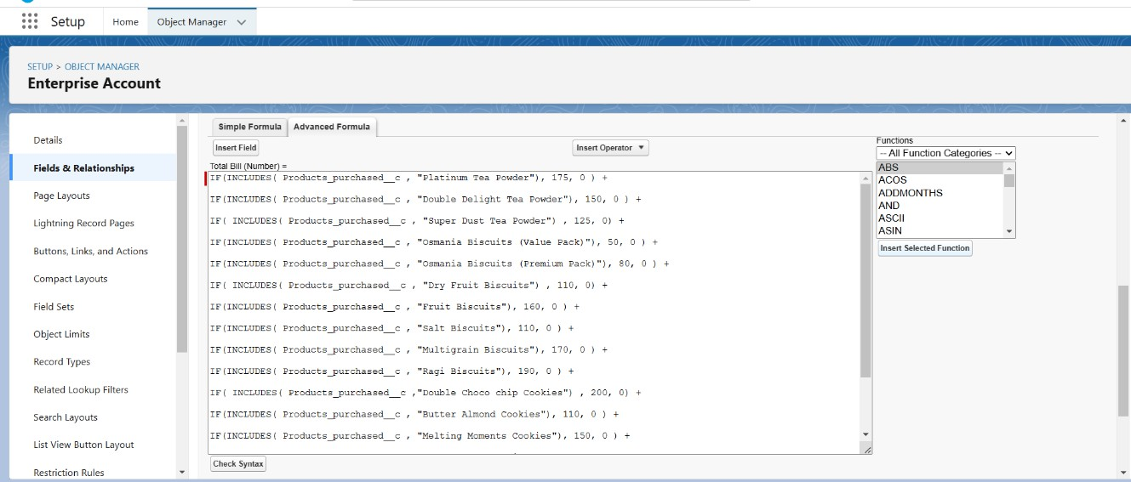

1. Payment mode (Picklist) Click save.

# Page Layouts:

Two page layouts are created. They are-

* + Online order page layouts
  + Walk-in order page layouts

To create the page layouts, go to set up and select object manager tab. Then select Customer account object from the dropdown.

Click on page layouts and click new.

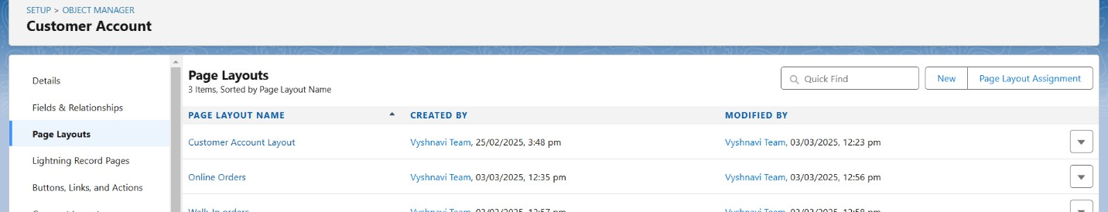

Page layout name: Online orders. Click save.

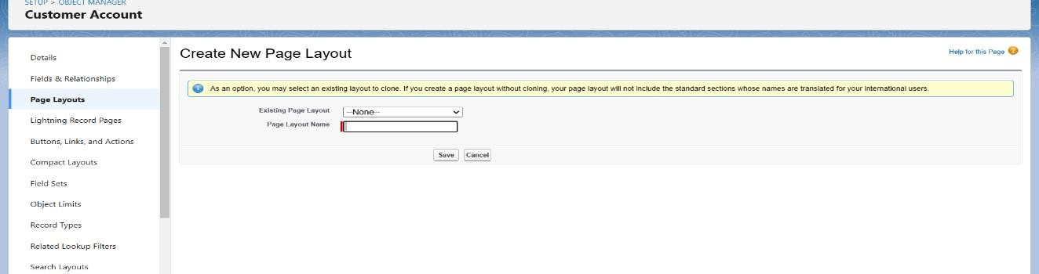

Drag and arrange the fields as below.

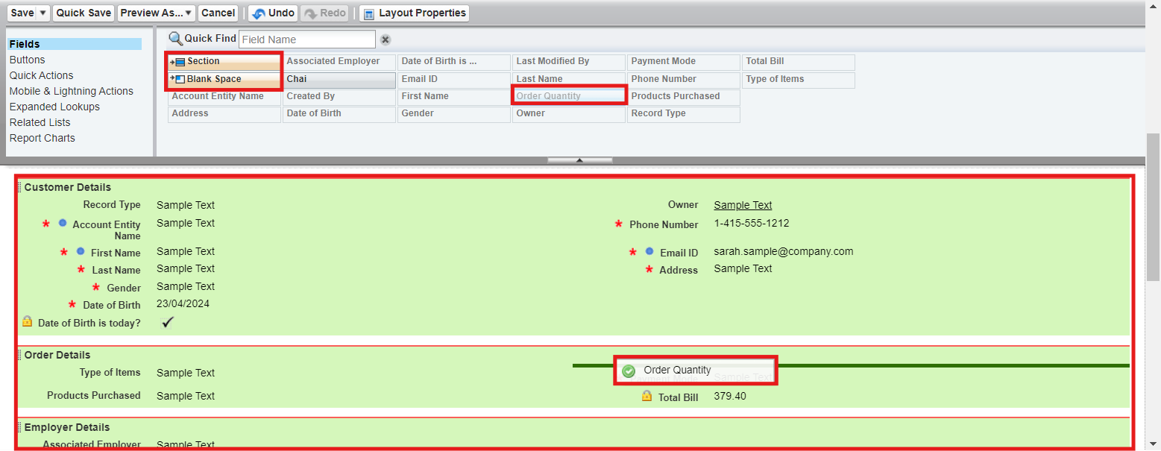

Click save.

Now repeat the same process to create walk-in orders page layout.

# Record types:

To create the record types, go to set up and select object manager tab. Then select Customer account object from the dropdown.

Select record types. Click new. Enter the details as shown.

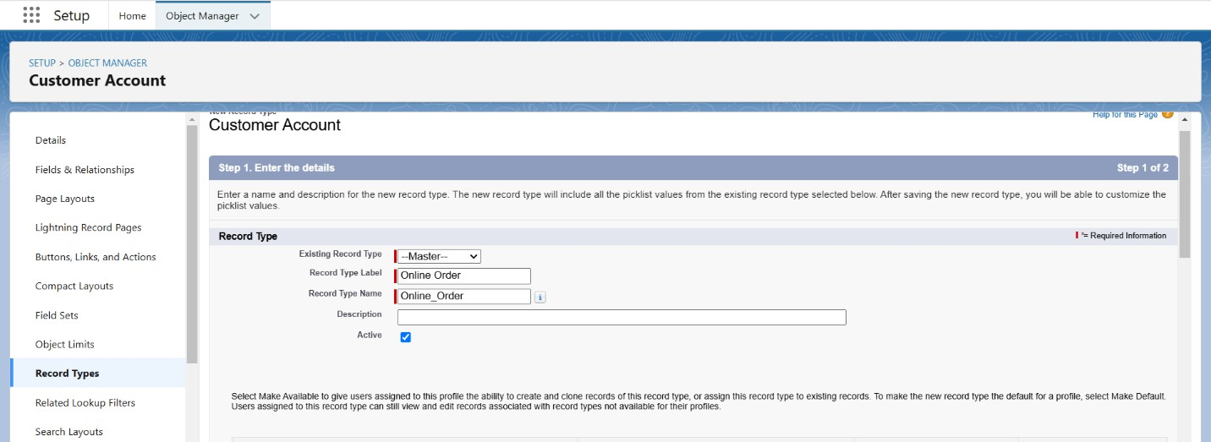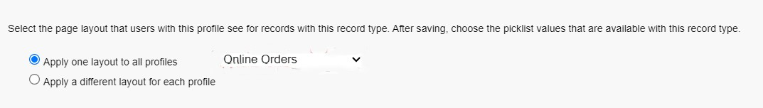

Click save & new and repeat the process to create walk-in orders record type.

# Validation rules:

To create the validation rules, go to employer account object through object manager tab.

Select validation rules and new.

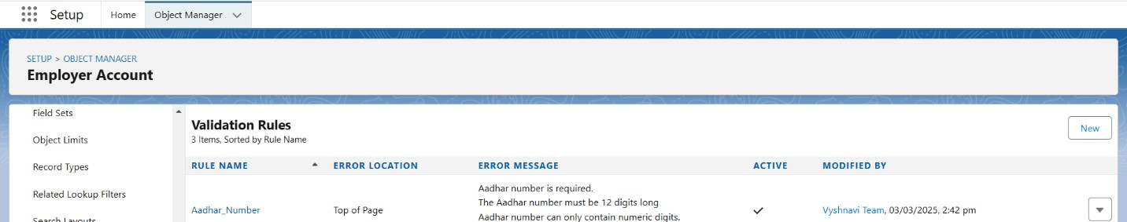

Enter rule name and error correction formula as shown below:

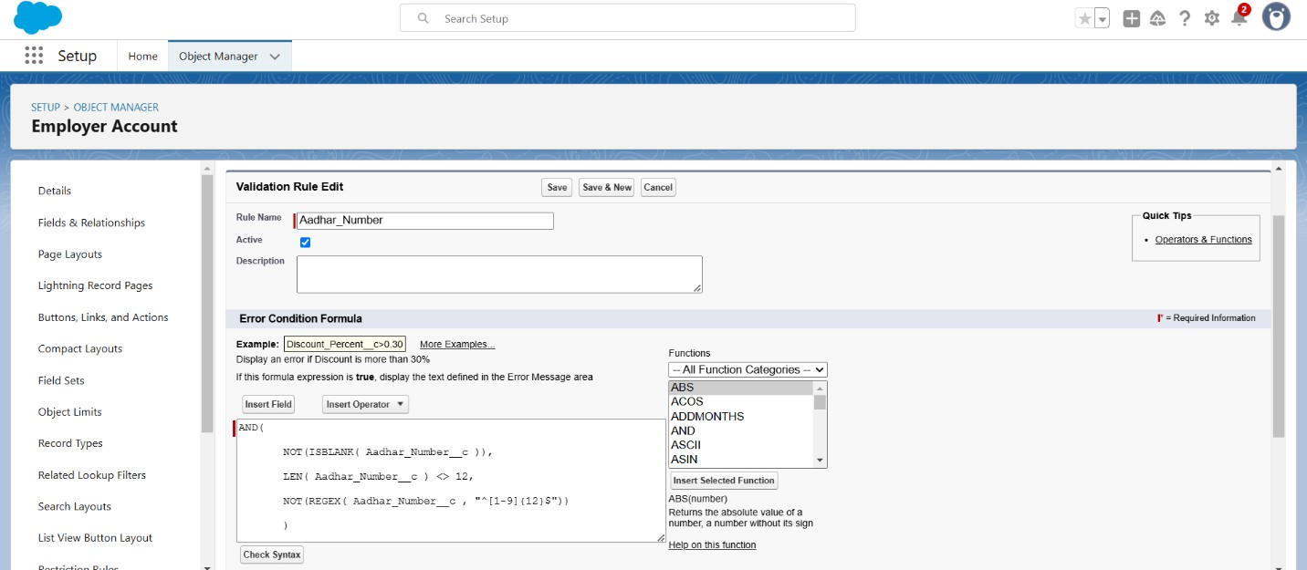

Error message is as follows:

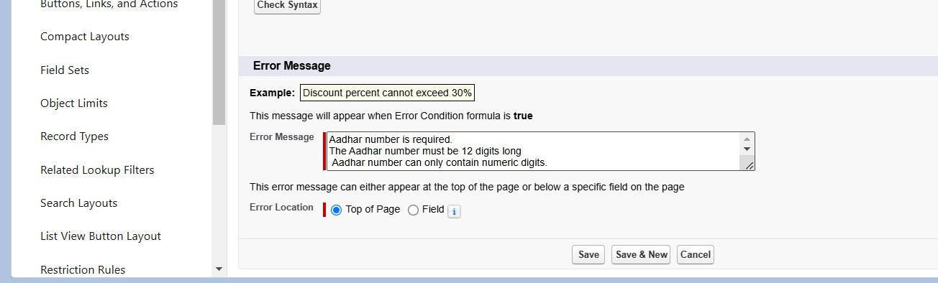

Repeat the same process to create two more validation rules for employer account object.

* + **Enter Rule Name**: PAN Number

## Error Condition Formula:

AND(

NOT(ISBLANK( Phone_Number c )), NOT(REGEX( Phone_Number c , "^[1-9]{10}$")), NOT(REGEX( Phone_Number c , "^\\d+$"))

)

**Error Message**: The PAN Details field must not be blank.

The PAN card number does not start with 0.

The PAN card number does not contain special characters.

* + **Enter Rule Name**: Phone Number

**Error Condition Formula**: AND(

NOT(ISBLANK( Phone_Number c )), NOT(REGEX( Phone_Number c , "^[1-9]{10}$")), NOT(REGEX( Phone_Number c , "^\\d+$"))

)

## Error Message :

The phone number field must not be blank.

The phone number must consist of exactly 10 digits. The phone number must contain only numeric digits (no spaces, dashes, parentheses, etc.)

Now repeat same process to create validation rules for customer account object as shown:

* + **Enter Rule Name**: Phone Number

## Error Condition Formula:

AND(

NOT(ISBLANK( Phone_Number c )), NOT(REGEX( Phone_Number c , "^[1-9]{10}$")), NOT(REGEX( Phone_Number c , "^\\d+$"))

)

## Error Message:

The phone number field must not be blank.

The phone number must consist of exactly 10 digits. The phone number must contain only numeric digits (no spaces, dashes, parentheses, etc.)

For enterprise account repeat the same.

* + Enter Rule Name : Phone Number Error Condition Formula :

AND(

NOT(ISBLANK( Phone_Number c )), NOT(REGEX( Phone_Number c , "^[1-9]{10}$")), NOT(REGEX( Phone_Number c , "^\\d+$"))

)

Error Message :

The phone number field must not be blank.

The phone number must consist of exactly 10 digits. The phone number must contain only numeric digits (no spaces, dashes, parentheses, etc.)

Click save.

# Email Template creation:

Go to quick find and search classic email templates. Click on new email template.

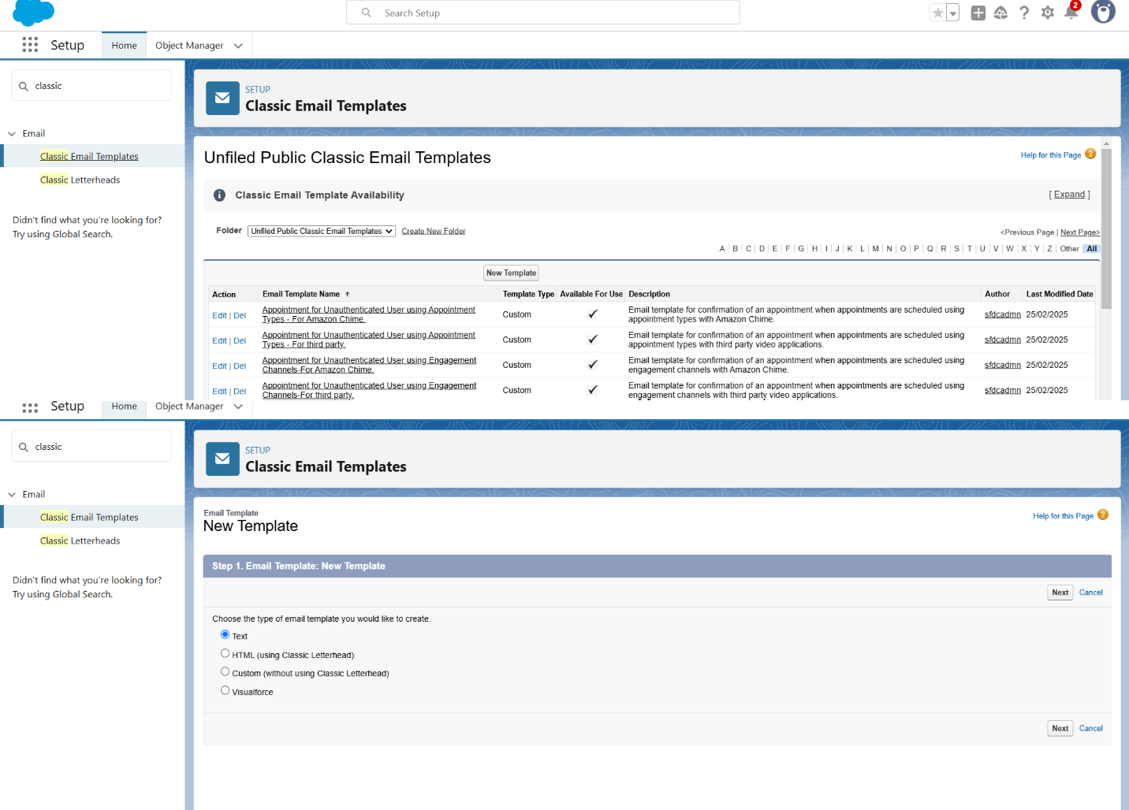

Fill the details as follows:

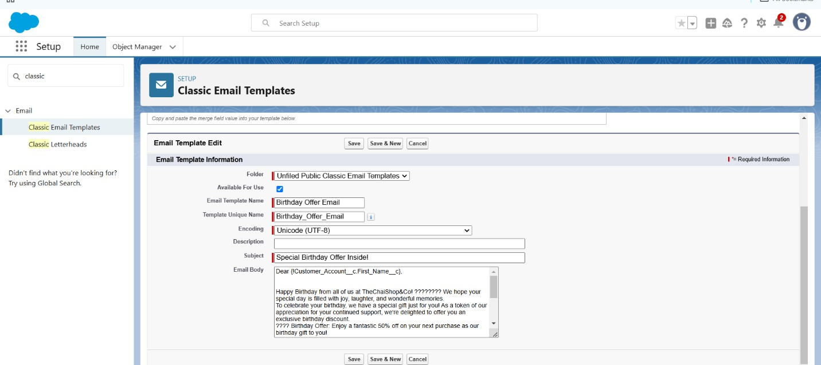

Click save.

For email alert creation, search for email alerts in quick find. Click on new email alert.

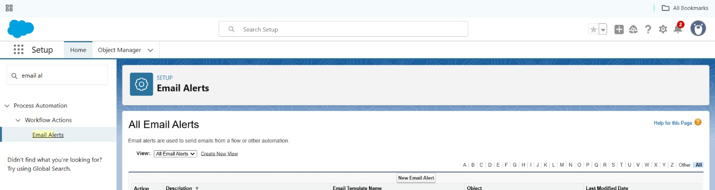

The details should be filled as shown:

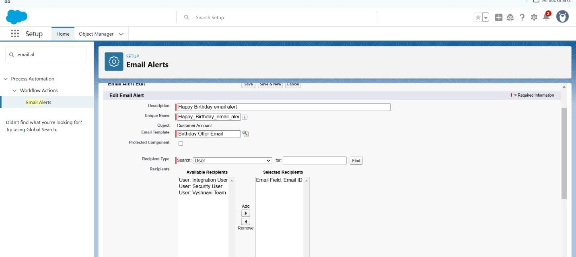

Make sure that the Default workflow user is assigned. Click save.

# Flows creation:

Go to quick find and search flows. Select new flow.

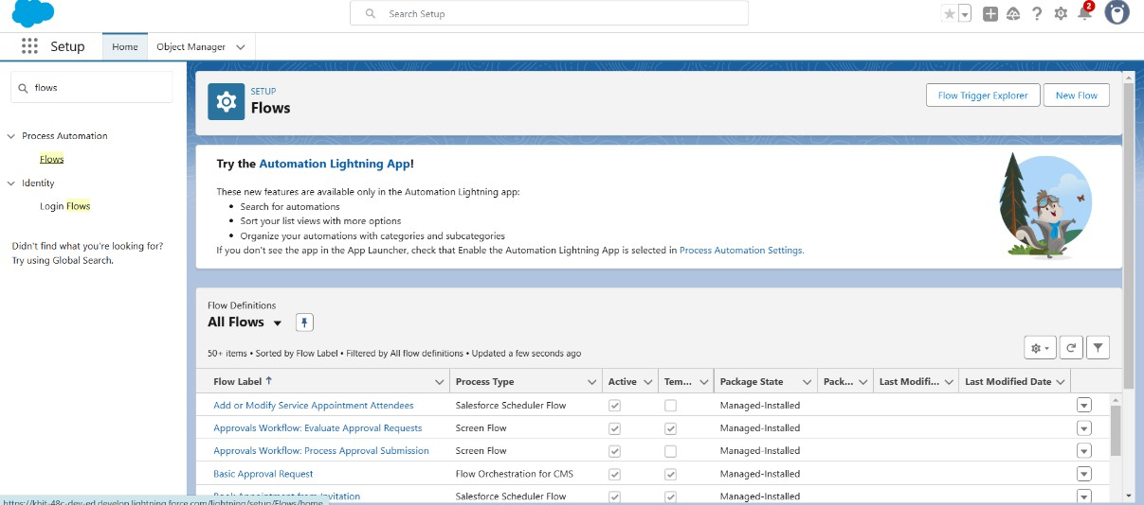

Select schedule-triggered flow and click create.

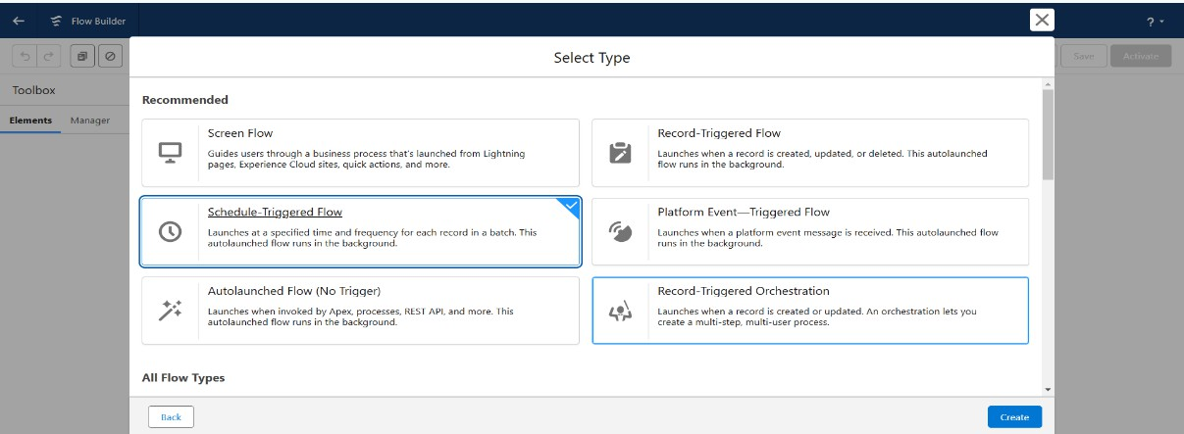

## Set a Schedule

Start Date: Enter the Date, when you want to start the flow. Start Time: Enter the Time, when you want to start the flow. Frequency: Daily

## Create Object

Object: Customer Account

Condition Requirements: All conditions Are Met (AND) Field: Date_of_Birthday_is_today c

Operator: Equals

Value: $GlobalConstant.True Field: Email_ID_c

Operator: IS NULL

Value: $GlobalConstant.False

Click + icon and add action component. In New Action Page

Filter By: Type and select Email Alert

In Action: Search and select Happy Birthday email alert Label: Send Happy Birthday Email

API Name: Auto Populates

Set Input Values for the Selected Action: Record ID: {!$Record.Id}

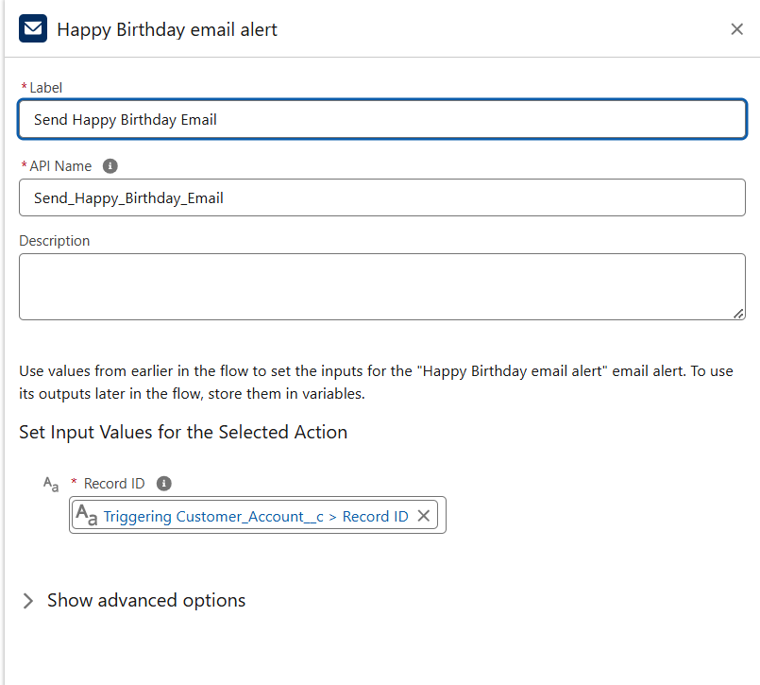

Now click done and save the flow as follows: Happy Birthday Email Flow

Activate the flow.

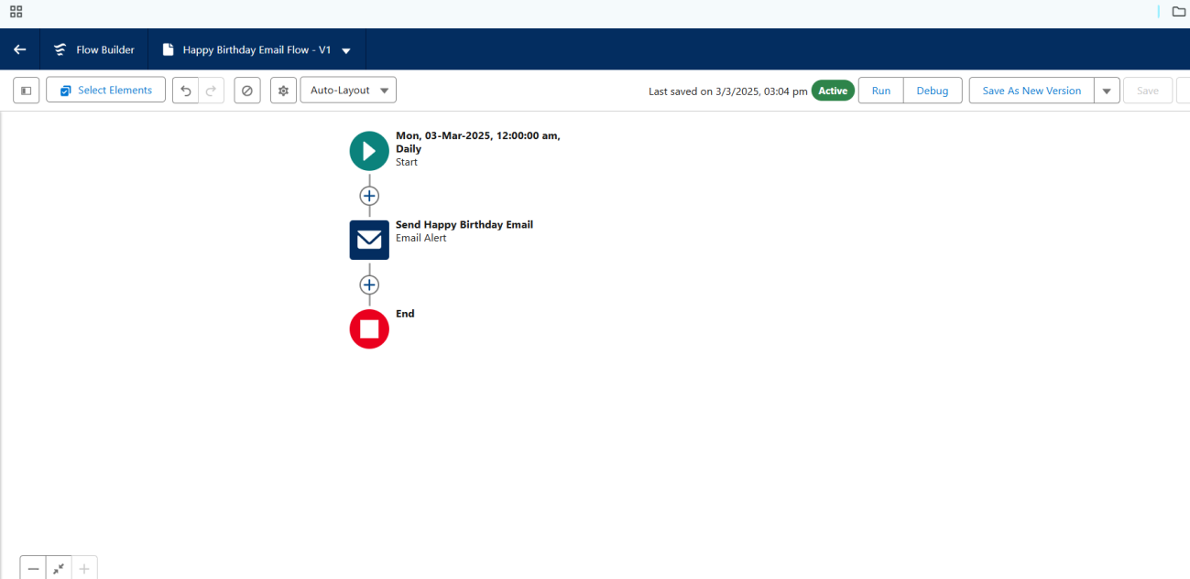

# Reports & Dashboards:

Click App Launcher  and select TheChaiShop&Co.

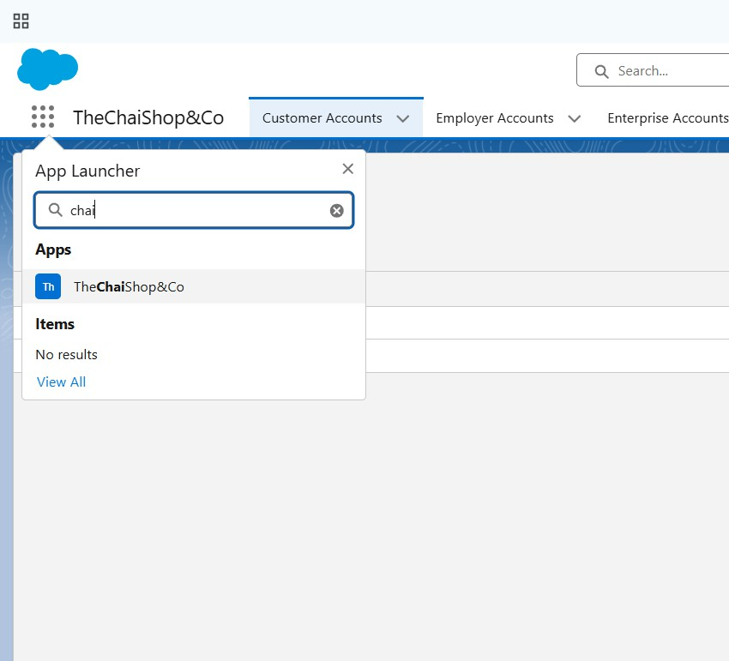

Click Reports Click New Report

In search type Customer Accounts and Select Customer Accounts. Click Start Report.

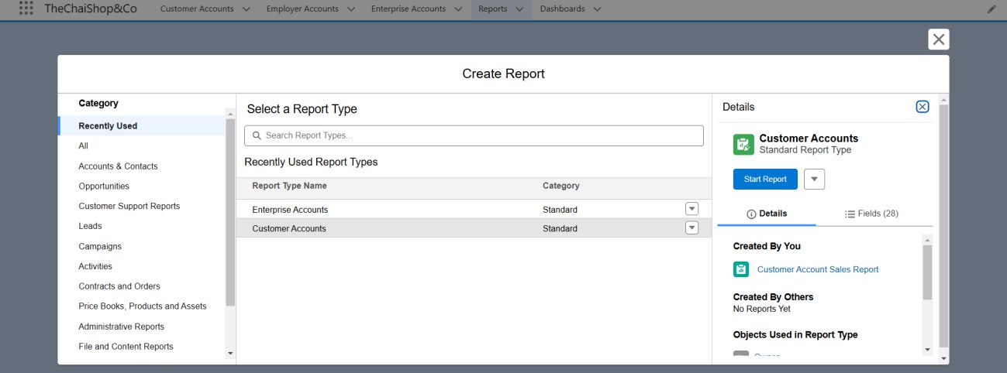

Group Rows: Search and Select Customer Account: Record Type

Click Add Chart on the top.

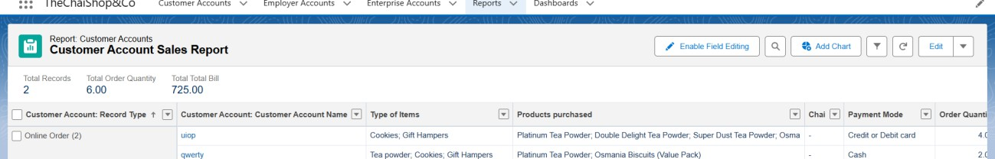

Click save with name Customer accounts sales report.

Repeat the same steps to create another report named Enterprise account sales report.

## Dashboards

Now go to dashboards and click new.

Create a dashboard named Customer vs Enterprise sales

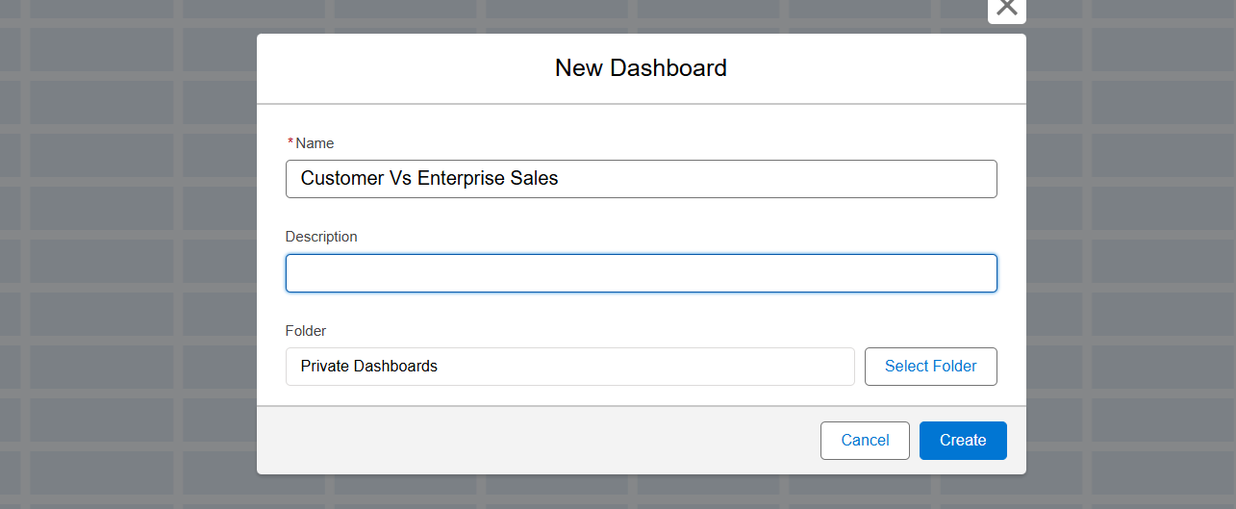

Click widget and chart/table. Select customer account sales report and click add.

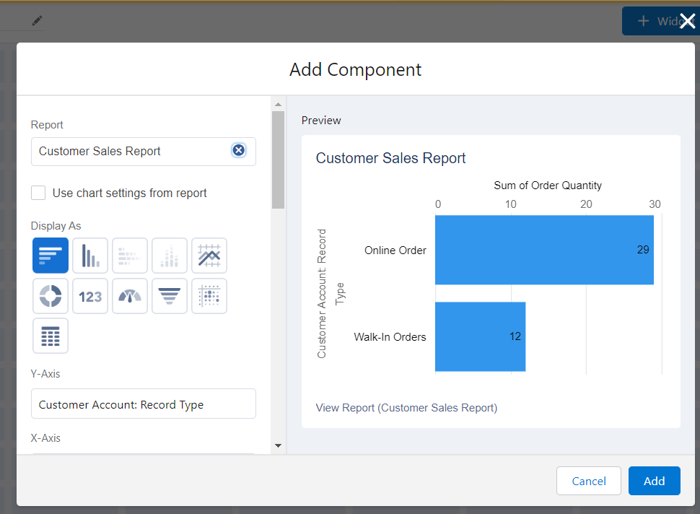

Repeat the same for enterprise account sales report. Save.

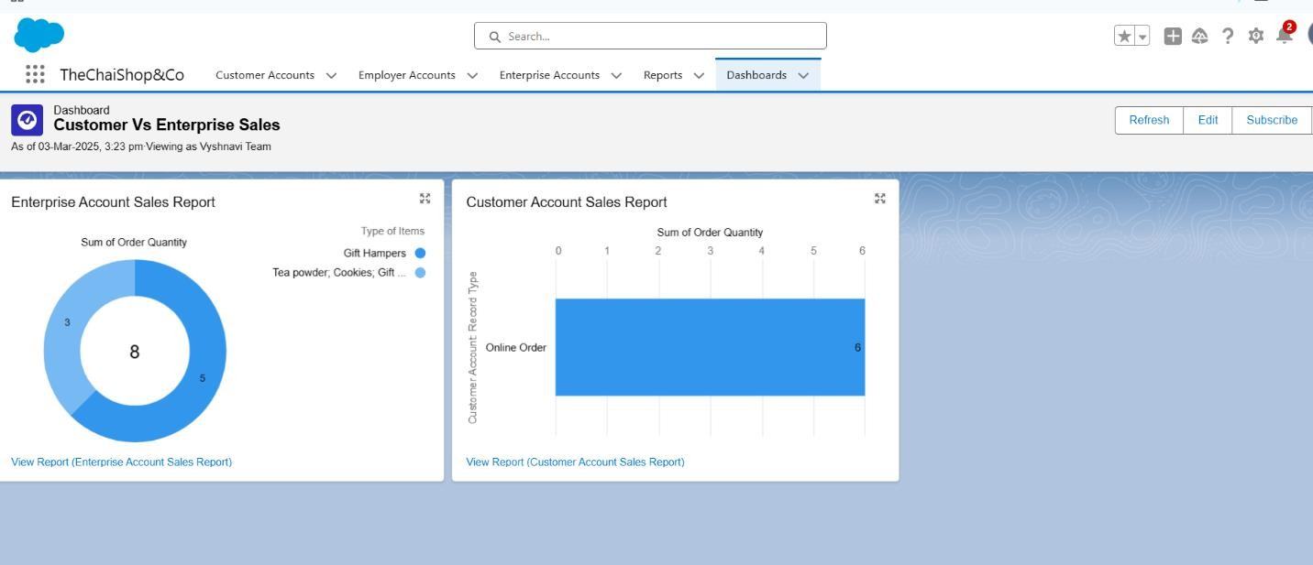

# Conclusion

The **CRM application for The Chai Shop & Co.** is a valuable tool that helps manage customer relationships, improve sales, and streamline daily operations. By using **Salesforce features like custom objects and tabs**, we have built a system that is easy to use, efficient, and tailored to the company’s needs.

This CRM makes it easier to track customer interactions, automate tasks, and make better business decisions. It also sets a strong foundation for future improvements, such as adding AI insights or marketing automation. With this system in place, **The Chai Shop & Co.** can provide better service, build stronger customer relationships, and grow its business effectively.